

CP Assignment 3

Name: Syed Muhammad Raza Ali

Enrolment: 02-134231-028

Course: CP

Faculty: Miss Azeema Sadia

# ASSIGNMENT No. 3

**Complex Computing Problem**

Course Title: Computer programming

Course Code: CSC-113

Class: BS (CS)-1A,B Submission deadline: 11-June -23

Course Instructor: Azeema Sadia Marks: 10

***__________________________________________________***

***Instructions***

1. Students will perform this assignment individually.
2. Assignment should be done only on A4 size paper and will also be uploaded on LMS
3. Deadline will not be extended for any reason.
4. Copied assignments will be marked zero
5. Make a single pdf as both soft copies and hard copy
6. Solution must be designed by applying the following characteristics

|  |  |
| --- | --- |
| **Characteristics** | **Problem Solving description** |
| Depth of analysis required | Has no obvious solution, and requires conceptual thinking and innovative analysis to formulate suitable abstract models |
| Depth of knowledge required | A solution requires the use of in-depth Computer Programming knowledge provided in class & lab sessions. |

**Scenario/Problem**

Develop a menu driven program in C++ for school library system that facilitates the school students and staff. Students can borrow books from library. The system enable the library staff to keep record of books by entering the correct credentials (login id and password).Your application must prompt a message in case of wrong credential entered. The staff can enter the book in a system with following information one by one.

* Book ID,
* Book Title, and
* Author Name

One book can be issued to the students at most for a month. Students must be 16 years old or above. While issuing a book to the students following information must be stored in a system.

* Student id,
* Name,
* Age,
* Book title,
* Book ISBN
* Duration.

**Deliverables**

A menu driven program with following functions. [CLO3, PLO4, BTL C3]

* + 1. User login
    2. Taking book record (store into a text file)
    3. Display particular book information(read from text file and then search specific book)
    4. Display all books(read from text file)
    5. Issue book to a student(takes reader’s information and will store it into a text file)

Add screen shots of your program and output in your solution file

**Evaluation Criteria**

|  |  |  |
| --- | --- | --- |
| **Deliverables** | **Evaluation Criteria** | **Target CLOs** |
| Application for school library (methods and operations) | **40%** | [CLO3, PLO4, BTL C3] |
| File Handling | **40%** | [CLO3, PLO4, BTL C3] |
| Viva | **20%** | [CLO2, PLO4, BTL C2] |

Code:

#include <iOStream>

#include <fstream>

#include <string>

using namespace std;

int i = 0;

string loginID, loginPassword, bookSearch;

char menuChoice, loopChoice;

ifstream bookin;

ofstream bookout;

//Book

struct book {

int bookID;

string bookTitle, authorName;

}bookObj[100];

//Student

struct student {

int studentID, studentAge, bookISBN, duration;

string studentName, bookTitle;

}studentObj[100];

void newbookRecord() {

cout << "============================================" << endl

<< " Enter a new book record" << endl

<< "============================================" << endl;

//taking book record

cout << "Enter the Book ID" << endl;

cin >> bookObj[i].bookID;

cout << "Enter the title of the book" << endl;

cin.ignore();

getline(cin, bookObj[i].bookTitle);

cout << "Enter the Name of the author" << endl;

getline(cin, bookObj[i].authorName);

//storing book record in file

bookin.open("book record.txt");

bookout.open("book record.txt", ios::app);

bookout << endl << "============================================" << endl

<< "Book ID: " << bookObj[i].bookID << endl

<< "Title: " << bookObj[i].bookTitle << endl

<< "Author: " << bookObj[i].authorName << endl;

cout << "Book record has been succesfully added to file" << endl;

bookin.close();

i = i + 1;

}

void bookrecordSearch() {

cout << "============================================" << endl

<< " Search for a Book record" << endl

<< "============================================" << endl;

cout << "Enter the ID of the book you want to search for" << endl;

cin.ignore();

getline(cin, bookSearch);

bookin.open("book record.txt");

string line, data;

int lineNo = 0;

bool found = false;

//searching for the book by id

while (getline(bookin, line)) {

if (line.find(bookSearch) != string::npos) {

cout << "book found!" << endl;

for (int j = 0; j < 2; j++) {

getline(bookin, data);

cout << data << endl;

}

found = true;

}

lineNo++;

}

if (found = false) {

cout << "Can't find the book you searched for :(" << endl;

}

bookin.close();

}

void allbookRecord() {

cout << "============================================" << endl

<< " All Books record";

string line;

bookin.open("book record.txt");

while (getline(bookin, line)) {

cout << line << endl;

}

bookin.close();

}

void studentData() {

cout << "============================================" << endl

<< " Issue book to a student" << endl

<< "============================================" << endl;

//taking students data

cout << "Enter Student ID" << endl;

cin >> studentObj[i].studentID;

cout << "Enter the Student Name" << endl;

getline(cin,studentObj[i].studentName);

cout << "Enter the age of the student" << endl;

cin >> studentObj[i].studentAge;

if (studentObj[i].studentAge >= 16) {

cout << "Enter the title of the book" << endl;

getline(cin,studentObj[i].bookTitle);

cout << "Enter the ISBN of the book" << endl;

cin >> studentObj[i].bookISBN;

cout << "Enter the duartion period of renting " << endl

<< "(you can rent a book for 30 days at most)" << endl;

cin >> studentObj[i].duration;

if (studentObj[i].duration >= 30) {

cout << "Error: you can only rent a book for 30 days at most!" << endl;

}

//storing student data in file

ifstream studentin;

ofstream studentout;

studentin.open("Student data.txt");

studentout.open("Student data.txt", ios::app);

studentout << endl << "============================================" << endl

<< "Student ID: " << studentObj[i].studentID

<< endl << "Student Name: " << studentObj[i].studentName

<< endl << "age of the student: " << studentObj[i].studentAge

<< endl << "title of the book: " << studentObj[i].bookTitle

<< endl << "ISBN of the book: " << studentObj[i].bookISBN

<< endl << "duartion period of renting: " << studentObj[i].duration << endl;

cout << "Student data stored successfully" << endl;

i = i + 1;

}

else {

cout << "You can't proceed further as your age is less than 16" << endl;

}

}

int main() {

cout << "============================================" << endl

<< " Welcome To The Library" << endl

<< "============================================" << endl;

cout << "Enter your login id" << endl;

cin >> loginID;

cout << "Enter your login password" << endl;

cin >> loginPassword;

do {

if (loginID == "admin" && loginPassword == "admin123") {

cout << "1. Enter a book record" << endl

<< "2. Display particular book information" << endl

<< "3. Display all books information" << endl

<< "4. Issue a book to a student" << endl;

cin >> menuChoice;

if (menuChoice == '1') {

newbookRecord();

}

else if (menuChoice == '2') {

bookrecordSearch();

}

else if (menuChoice == '3') {

allbookRecord();

}

else if (menuChoice == '4') {

studentData();

}

}

else if (loginID == "admin" && loginPassword != "admin123") {

cout << "The password you entered is not correct" << endl;

}

else if (loginID != "admin" && loginPassword == "admin123") {

cout << "The login ID you entered is not correct" << endl;

}

else {

cout << "You entered wrong credentials" << endl;

}

cout << "Press Y if you want to continue or any other key to exit" << endl;

cin >> loopChoice;

} while (loopChoice == 'y' || loopChoice == 'Y');

return 0;

}

Outputs:

1. Login

The login id for admin to log in is “admin” and password is “admin123”, in case of wrong credentials a message will be printed on the console saying “you entered wrong credentials”

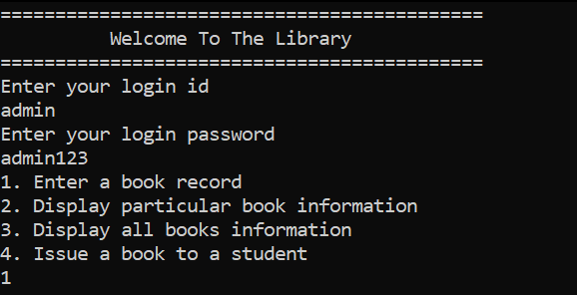

1. Entering book records (from console)

Three book records have been entered in the program and there record is also saved in the text file.

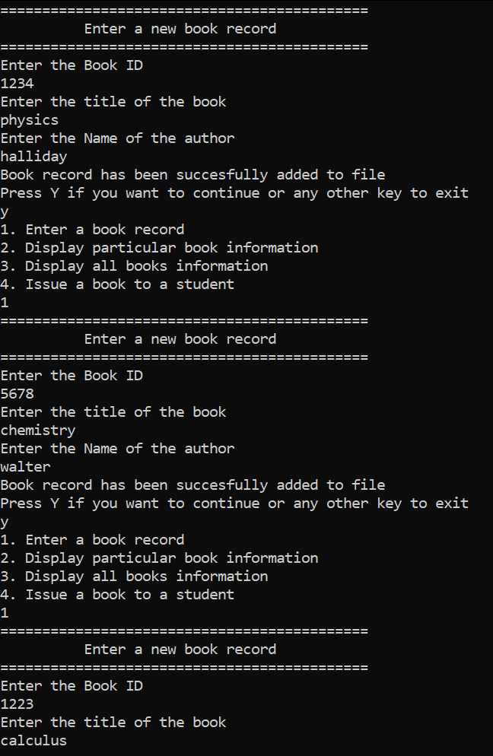

1. Entering book records (in file)

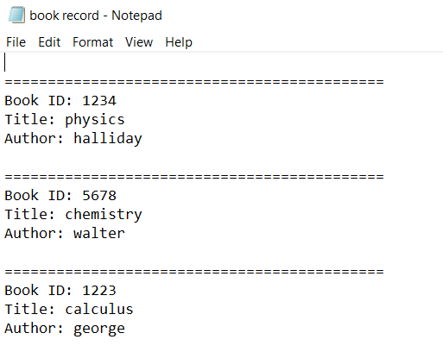

1. Displaying a particular book record

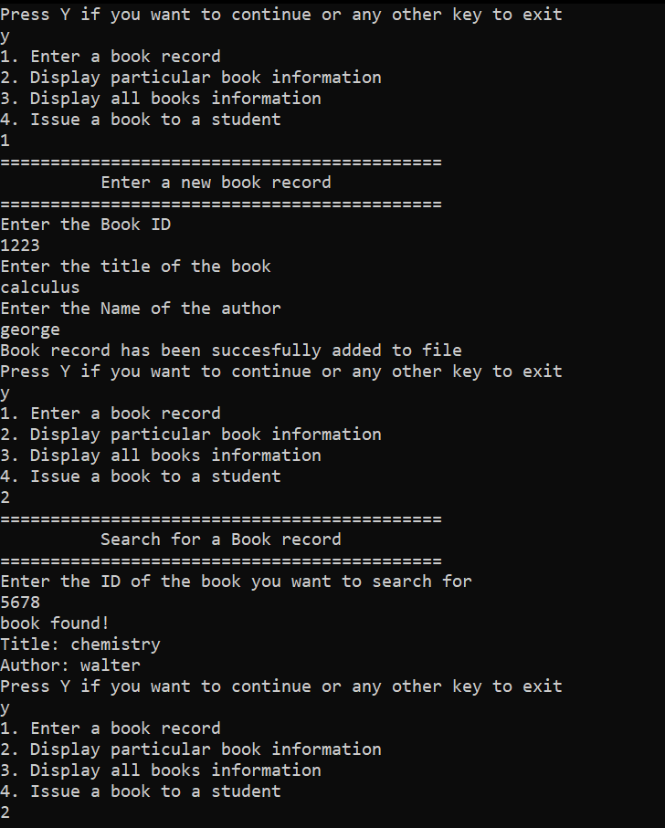The books are searched from their ID number and a loop is used to search for the book in the file. After the book is found, its record is diplayed on the console from the file.

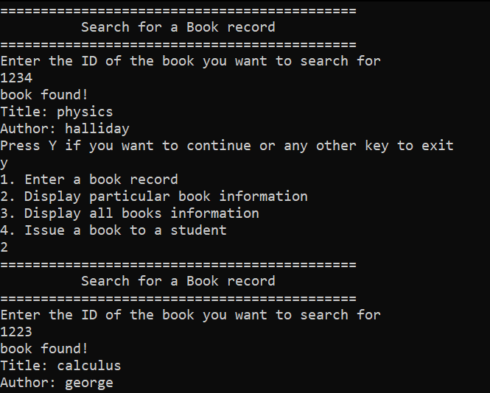

1. Displaying all books record

A loop is used to read the file line by line and then the data is printed on the console.

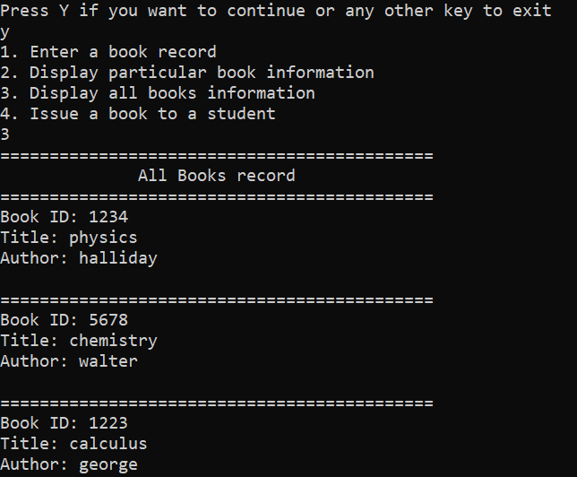

1. Issuing a book to a student (Entering data in console)

The data of the student is being stored in the structure and the file.

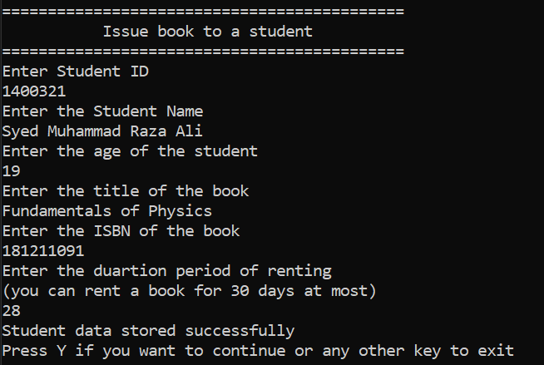

1. Issuing a book to a student (in the file)

